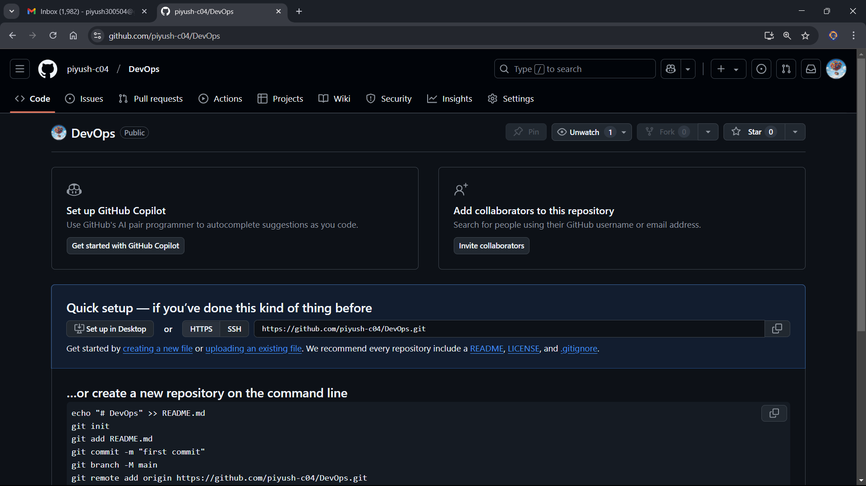D:\10 pointer\Sem 6 DJ\DevOps>git init

Initialized empty Git repository in D:/10 pointer/Sem 6 DJ/DevOps/.git/

D:\10 pointer\Sem 6 DJ\DevOps>git status

On branch master

No commits yet

nothing to commit (create/copy files and use "git add" to track)

D:\10 pointer\Sem 6 DJ\DevOps>git status

On branch master

No commits yet

Untracked files:

(use "git add <file>..." to include in what will be committed)

exp1.txt

nothing added to commit but untracked files present (use "git add" to track)

D:\10 pointer\Sem 6 DJ\DevOps>git add .

D:\10 pointer\Sem 6 DJ\DevOps>git status

On branch master

No commits yet

Changes to be committed:

(use "git rm --cached <file>..." to unstage)

new file: exp1.txt

D:\10 pointer\Sem 6 DJ\DevOps>git commit -m "This is the first file to be committed"

[master (root-commit) a618fb2] This is the first file to be committed

1 file changed, 0 insertions(+), 0 deletions(-)

create mode 100644 exp1.txt

D:\10 pointer\Sem 6 DJ\DevOps>git status

On branch master

nothing to commit, working tree clean

D:\10 pointer\Sem 6 DJ\DevOps>git branch -M main

D:\10 pointer\Sem 6 DJ\DevOps>git remote add origin https://github.com/piyush-c04/DevOps.git

D:\10 pointer\Sem 6 DJ\DevOps>git push -u origin main

Enumerating objects: 3, done.

Counting objects: 100% (3/3), done.

Writing objects: 100% (3/3), 241 bytes | 241.00 KiB/s, done.

Total 3 (delta 0), reused 0 (delta 0), pack-reused 0 (from 0)

To https://github.com/piyush-c04/DevOps.git

\* [new branch] main -> main

branch 'main' set up to track 'origin/main'.

D:\10 pointer\Sem 6 DJ\DevOps>git status

On branch main

Your branch is up to date with 'origin/main'.

nothing to commit, working tree clean

